Draft Final Report

**In Vivo Rat Pharmacokinetic Studies for 8 Environmental Compounds**

SUBMITTED TO:

Environmental Protection Agency

Research Triangle Park, NC 27709

SUBMITTED BY:

RTI International*

3040 Cornwallis Road

P.O. Box 12194

Research Triangle Park, NC 27709-2194

**RTI Report No.** RTI 0214399.000

**December 18, 2014**

|  |
| --- |
|  |
| Timothy R. Fennell, Ph.D.  Study Director |

\**RTI International is a trade name of Research Triangle Institute.*

# Objective:

To determine plasma concentrations of 8 environmental compounds following intravenous and gavage administration to rats. The plasma concentration versus time data will facilitate development of pharmacokinetic parameters and determination of bioavailability of these compounds.

# Materials:

## Test Articles

RTI received the test articles from suppliers as shown in Table 1. While two different lots of flufenacet and pyrithiobac sodium were received, only the lot number of each shown in bold type in Table 1 was used. Each of the test articles received from Sigma Aldrich was PESTANAL® grade.

## Other chemicals

Details on suppliers and lot numbers for the internal standards and dose vehicle components ethanol, Cremophor and phosphate buffered saline are shown in Table 2.

Table 1. Test Articles

|  |  |  |  |  |  |
| --- | --- | --- | --- | --- | --- |
| Test Article | CAS # | Supplier | Lot Number | Manufacturer’s Purity | MW (g/mol |
| 2,4-D | 94-75-7 | Sigma Aldrich | SZBA102XV | 99.8 | 221.04 |
| Alachlor | 15972-60-8 | Sigma Aldrich | SZB9139XV | 99.2 | 269.77 |
| Flufenacet | 142459-58-3 | Sigma Aldrich | SZBA029XV  **SZBD038XV** | 99.8  99.5 | 363.33 |
| Chloridazon | 1698-60-8 | Sigma Aldrich | SZBD100XV | 99.7 | 221.64 |
| Bensulide | 741-58-2 | Sigma Aldrich | SZBD044XV | 99.3 | 397.51 |
| Propyzamide | 23950-58-5 | Sigma Aldrich | SZB9023XV | 99.6 | 256.13 |
| Pyrithiobac sodium | 123343-16-8 | Crescent Chemical Co | 10211  **40722** | 99.5  99.0 | 348.70 |
| Diazinon-o-analog | 962-58-3 | Crescent Chemical Co | 2645800 | 97 | 288.30 |

Table 2. Internal Standards and Vehicle Components

|  |  |  |  |  |
| --- | --- | --- | --- | --- |
| Compound | CAS # | Supplier | Lot # | Purity |
| Isoxaben (internal std) | 82558-50-7 | Sigma Aldrich | SZX8092XV | 97.6 |
| 2-methyl-4-chlorophenylacetic acid (MCPA, internal standard | 94-74-6 | Sigma Aldrich | SZB129XV |  |
| EtOH | 64-17-5 | Decon Laboratories | None | 200 proof USP grade |
| Cremophor | 61791-12-6 | Sigma | BCBB1383 |  |
| PBS | NA | Amresco | 1974C491 |  |

# Methods

## Test article characterization

A 1H NMR (Bruker 300 MHz) of each test article was obtained to confirm identity and assess purity. The NMR spectra are shown in Appendix 1. In addition, each test article was analyzed by HPLC with UV detection.

## Test System

Sixty-four male Sprague Dawley rats with indwelling jugular vein catheters (JVC) were obtained from Charles River Laboratories, Raleigh. Rats were 8-10 weeks old at receipt. Rats were housed singly in polycarbonate cages with Sanichips bedding (PJ Murphy Forest Products) and stainless steel wire lids that accommodate a water bottle and feed. Rats were offered Purina 5001 feed and water (Durham City, NC) from a reverse osmosis system ad libitum. Rats were received 1-2 days following JVC surgery and were acclimated to the facility for 4 days prior to dosing. Each rat was identified by an eartag and the rats were randomized prior to assignment to groups.

## Formulation Development

Each test article was tested for solubility first in phosphate buffered saline (PBS) at the concentrations needed for the dose formulation (see Table 3). Any test articles that were not soluble in PBS at the required concentration were next tested for solubility in a vehicle consisting of 10:30:60 (v:v:v) EtOH: Cremophor: PBS (ECP). For this test, the compound was first dissolved in ethanol and then Cremophor and PBS were added sequentially. The final vehicle used for each test article is presented in Table 3.

## Dose Preparation and Administration

Details of the dose formulation preparation for each test article are shown in Table 3. The same formulation was used for gavage and intravenous doses for each compound, with a gavage dose volume of 5 mL/kg and an intravenous dose volume of 1 mL/kg. Doses were prepared the day prior to use and were stored at 4⁰C overnight. Rats were weighed on the morning of dosing and the dose was calculated based on rat weight, formulation concentration and target dose (mg/kg). Dose administered was calculated from the difference in the full and empty (post dosing) syringe weight (g) times the dose concentration (mg/g) and divided by the rat body weight (kg). Gavage doses were administered using a syringe equipped with a ball-tipped feeding needle (18G). Intravenous doses were administered via a lateral tail vein with a syringe equipped with a 27 G needle. The dose administration record is presented in Table 4. Body weight data and dose administered, dosing time and sample collection time were collected using the Debra™ Data Collection System (Lablogic Systems Ltd, Sheffield, UK).

Table 3. Dose Formulation Detail

|  |  |  |  |  |  |  |
| --- | --- | --- | --- | --- | --- | --- |
| Group | Test Article | Test article weight (mg) | Vehicle | Vehicle Volume (mL) | Total formulation weight (g) | Final Formulation Concentration (mg/g) |
| 1 and 2 | 2,4-D | 5.14 | ECP | 25.70 | 25.56779 | 0.200 |
| 3 and 4 | Alachlor | 24.73 | ECP | 24.73 | 24.69203 | 1.002 |
| 5 and 6 | Flufenacet | 25.81 | ECP | 25.81 | 25.72673 | 1.003 |
| 7 and 8 | Chloridazon | 20.51 | ECP | 25.64 | 25.47093 | 0.805 |
| 9 and 10 | Bensulide | 22.82 | ECP | 22.82 | 22.61595 | 1.009 |
| 11 and 12 | Propyzamide | 15.59 | ECP | 25.98 | 25.79944 | 0.604 |
| 13 and 14 | Pyrithiobac-Na | 5.04 | PBS | 25.20 | 25.04052 | 0.201 |
| 15 and 16 | Diazoxon | 26.96 | PBS | 26.96 | 26.43139 | 1.020 |

Table 4. Dose Administration Record

| Subject | Route | Test Article | Subject Wt (g) | Weight of Dose Formulation Administered (g) | Test Article Dosed (g) | Actual Dose Rate (mg/kg) |
| --- | --- | --- | --- | --- | --- | --- |
| 1-001 | IV | 2,4-D | 305.03 | 0.3093 | 0.0619 | 0.203 |
| 1-002 | IV | 2,4-D | 326.91 | 0.33 | 0.066 | 0.202 |
| 1-003 | IV | 2,4-D | 334.85 | 0.3504 | 0.0701 | 0.209 |
| 2-001 | Gavage | 2,4-D | 314.67 | 1.641 | 0.3282 | 1.043 |
| 2-002 | Gavage | 2,4-D | 333.48 | 1.7395 | 0.3479 | 1.043 |
| 2-003 | Gavage | 2,4-D | 329.54 | 1.7164 | 0.3433 | 1.042 |
| 3-001 | IV | Alachlor | 313.16 | 0.3181 | 0.3187 | 1.018 |
| 3-002 | IV | Alachlor | 328.38 | 0.3192 | 0.3198 | 0.974 |
| 3-003 | IV | Alachlor | 338.94 | 0.3417 | 0.3424 | 1.01 |
| 4-001 | Gavage | Alachlor | 332.21 | 1.7169 | 1.7203 | 5.178 |
| 4-002 | Gavage | Alachlor | 307.98 | 1.589 | 1.5922 | 5.17 |
| 4-003 | Gavage | Alachlor | 332.61 | 1.7478 | 1.7513 | 5.265 |
| 5-001 | IV | Flufenacet | 310.06 | 0.3066 | 0.3075 | 0.992 |
| 5-002 | IV | Flufenacet | 333.05 | 0.3262 | 0.3272 | 0.982 |
| 5-003 | IV | Flufenacet | 313.62 | 0.3164 | 0.3173 | 1.012 |
| 6-001 | Gavage | Flufenacet | 338.64 | 1.7904 | 1.7958 | 5.303 |
| 6-002 | Gavage | Flufenacet | 324.61 | 1.6698 | 1.6748 | 5.159 |
| 6-003 | Gavage | Flufenacet | 327.96 | 1.6781 | 1.6831 | 5.132 |
| 7-001 | IV | Chloridazon | 334.01 | 0.3045 | 0.2451 | 0.734 |
| 7-002 | IV | Chloridazon | 323.01 | 0.3317 | 0.267 | 0.827 |
| 7-003 | IV | Chloridazon | 318.46 | 0.3351 | 0.2698 | 0.847 |
| 8-001 | Gavage | Chloridazon | 341.26 | 1.773 | 1.4273 | 4.182 |
| 8-002 | Gavage | Chloridazon | 332.34 | 1.6999 | 1.3684 | 4.118 |
| 8-003 | Gavage | Chloridazon | 320.18 | 1.6688 | 1.3434 | 4.196 |
| 9-001 | IV | Bensulide | 333.58 | 0.3348 | 0.3378 | 1.013 |
| 9-002 | IV | Bensulide | 323.68 | 0.3159 | 0.3187 | 0.985 |
| 9-003 | IV | Bensulide | 326.37 | 0.3336 | 0.3366 | 1.031 |
| 10-001 | Gavage | Bensulide | 339.69 | 1.7709 | 1.7868 | 5.26 |
| 10-002 | Gavage | Bensulide | 338.94 | 1.7168 | 1.7323 | 5.111 |
| 10-003 | Gavage | Bensulide | 320.53 | 1.6422 | 1.657 | 5.169 |
| 11-001 | IV | Propyzamide | 343.78 | 0.3435 | 0.2075 | 0.604 |
| 11-002 | IV | Propyzamide | 310.88 | 0.316 | 0.1909 | 0.614 |
| 11-003 | IV | Propyzamide | 341.76 | 0.343 | 0.2072 | 0.606 |
| 12-001 | Gavage | Propyzamide | 310.23 | 1.6498 | 0.9965 | 3.212 |
| 12-002 | Gavage | Propyzamide | 314.95 | 1.6173 | 0.9768 | 3.102 |
| 12-003 | Gavage | Propyzamide | 316.85 | 1.6087 | 0.9717 | 3.067 |
| 13-001 | IV | Pyrithiobac Na | 343.54 | 0.3632 | 0.0731 | 0.213 |
| 13-002 | IV | Pyrithiobac Na | 332.3 | 0.3314 | 0.0667 | 0.201 |
| 13-003 | IV | Pyrithiobac Na | 334.46 | 0.3218 | 0.0647 | 0.194 |
| 14-001 | Gavage | Pyrithiobac Na | 341.62 | 1.7581 | 0.3537 | 1.035 |
| 14-002 | Gavage | Pyrithiobac Na | 347.4 | 1.7773 | 0.3576 | 1.029 |
| 14-003 | Gavage | Pyrithiobac Na | 331.87 | 1.7281 | 0.3477 | 1.048 |
| 15-001 | IV | Diazoxon | 342.69 | 0.3412 | 0.348 | 1.016 |
| 15-002 | IV | Diazoxon | 338.03 | 0.3268 | 0.3333 | 0.986 |
| 15-003 | IV | Diazoxon | 333.44 | 0.3474 | 0.3543 | 1.063 |
| 16-001 | Gavage | Diazoxon | 334.43 | 1.643 | 1.6759 | 5.011 |
| 16-002 | Gavage | Diazoxon | 341.18 | 1.6942 | 1.7281 | 5.065 |
| 16-003 | Gavage | Diazoxon | 340.23 | 1.6641 | 1.6974 | 4.989 |

## Sample Collection

Blood was sampled from the jugular catheter at 0 (predose), 5 (IV only), 10 (IV only), 15 (gavage only), and 30 min and 1, 2, 4, 8, 24, 48 and 72 h post dose administration. Blood volume removed was replaced with saline and 60 µL of 50 units heparin/mL was used as a catheter lock. Each 300 µL blood sample was immediately dispensed into heparinized tubes and placed on ice. Plasma was prepared by centrifugation (1500 *g*, 10 min, 4 °C) within 1 h of blood collection. Plasma was divided into 2 x 25 µL aliquots in 1.5 mL microcentrifuge tubes with the remaining volume stored in a separate 1.5 mL microcentrifuge tube. All plasma was frozen on dry ice at collection and then was stored at -70 °C until analyzed.

## Dose Analysis

Dose formulation concentrations were analyzed using HPLC UV methods. Standard curves were prepared using solutions of known concentration of standards in methanol. Dose formulations were diluted (1:1) in triplicate in methanol for analysis.

## Sample Analysis

LC/MS/MS methods were developed for each compound and the method details are presented in Tables 5-8.

Plasma (25 µL) was thawed on ice and was mixed with 5 µL of methanol and 100 µL of ice cold methanol containing 100 ng/mL of internal standard (IS); isoxaben for positive ionization methods and MCPA for negative ionization. Samples were vortexed (5 seconds on a Vortex Genie 2 at maximum speed) and centrifuged at 16*g* for 3 minutes in a VWR Microcentrifuge. Supernatant (100 µL) was mixed with 100 µL of mobile phase (0.1 % formic acid in water or 10 mM NH4OAc). Samples (10 µL) were analyzed by LC-MS/MS.

Standard curves and QC samples were prepared similarly by mixing 5 µL of methanol containing a known amount of test article (instead of 5 µL methanol only) to 25 µL plasma and processing as described above for samples. Standard curve ranges are shown in Table 9.

Table 5  
  
LC/MS Methods Instrumentation and Analysis Parameters for Flufenacet, Bensulide and Propyzamide

Instrumentation

| **Mass Spectrometer** | API 4000 Triple Quadrupole with Turbo Ion Spray source (Beryllium) |
| --- | --- |
| **HPLC** | Agilent 1100 Binary Pumps, Autosampler, Diode Array Detector and Column Compartment |

Chromatography Conditions

| **Column** | Restek Ultra C18 (50 x 2 mm, 5 μm) with C18 guard cartridge |
| --- | --- |
| **Injection Volume** | 10 microliters |
| **Mobile Phase** | A: 0.1% Formic Acid in Water; B: Methanol |
| **Flow Rate** | 0.3 mL/min |
| **Gradient** | Initially 20% B, changing linearly to 100% B over 4.5 min, beginning 0.5 min post injection. Hold at 100% B for 1 min, then return to initial conditions over 0.5 min |
| **Internal Standard** | Isoxaben – MRM (333.198 → 167.7), DP=61, CE=23, CXP=12 |

MS Parameters

| **Parameter** | **Flufenacet** | **Bensulide** | **Propyzamide** |
| --- | --- | --- | --- |
| Polarity | Positive | Positive | Positive |
| Ion Source | TurboSpray | TurboSpray | TurboSpray |
| Time | 75 msec | 75 msec | 75 msec |
| Curtain Gas | 14 | 14 | 14 |
| Gas 1 | 60 | 60 | 60 |
| Gas 2 | 60 | 60 | 60 |
| IonSpray Voltage | 2000 | 2000 | 2000 |
| Source Temperature | 550 | 550 | 550 |
| Collision Gas (CAD) | 10 | 10 | 10 |
| Declustering Potential | 51 | 61 | 51 |
| Entrance Potential | 10 | 10 | 10 |
| Collision Cell Exit Potential | 10 | 10 | 12 |
| Collision Energy | 17 | 29 | 19 |
| MRM | 363.9 → 193.9 | 398.0 → 157.9 | 256.0 → 189.5 |

Table 6  
  
LC/MS Methods Instrumentation and Analysis Parameters for 2,4-D

Instrumentation

| **Mass Spectrometer** | API 4000 Triple Quadrupole with Turbo Ion Spray source (Beryllium) |
| --- | --- |
| **HPLC** | Agilent 1100 Binary Pumps, Autosampler, Diode Array Detector and Column Compartment |

Chromatography Conditions

| **Column** | Restek Ultra C18 (50 x 2 mm, 5 μm) with C18 guard cartridge |
| --- | --- |
| **Injection Volume** | 10 microliters |
| **Mobile Phase** | A: 0.1% Acetic Acid + 10 mM Ammonium Acetate in Water; B: Methanol |
| **Flow Rate** | 0.3 mL/min |
| **Gradient** | Initially 5% B, changing linearly to 100% B over 4.5 min, beginning 0.5 min post injection. Hold at 100% B for 1 min, then return to initial conditions over 0.5 min |
| **Internal Standard** | MCPA – MRM (198.84 → 140.5), DP=-45, CE=-20, CXP=-11 |

MS Parameters

| **Parameter** | **2,4-D** |
| --- | --- |
| Polarity | Negative |
| Ion Source | TurboSpray |
| Time | 75 msec |
| Curtain Gas | 14 |
| Gas 1 | 60 |
| Gas 2 | 60 |
| IonSpray Voltage | 2000 |
| Source Temperature | 550 |
| Collision Gas (CAD) | 10 |
| Declustering Potential | -45 |
| Entrance Potential | -10 |
| Collision Cell Exit Potential | -11 |
| Collision Energy | -18 |
| MRM | 218.758 → 160.6 |

Table 7   
  
LC/MS Methods Instrumentation and Analysis Parameters for Chloridazon, Diazoxon and the Diazoxon Metabolite IMP

Instrumentation

| **Mass Spectrometer** | API 5000 Triple Quadrupole with Turbo Ion Spray source (Cobalt) |
| --- | --- |
| **HPLC** | Waters Acquity UPLC System |

Chromatography Conditions

| **Column** | Phenomenex Synergi Hydro-RP (50 x 2 mm, 4 μm) with C18 guard cartridge |
| --- | --- |
| **Injection Volume** | 10 microliters |
| **Mobile Phase** | A: 0.1% Formic Acid in Water; B: Methanol |
| **Flow Rate** | 0.5 mL/min |
| **Gradient** | Initially 20% B, changing linearly to 100% B over 4.5 min, beginning 0.5 min post injection. Hold at 100% B for 1 min, then return to initial conditions over 0.5 min |
| **Internal Standard** | Isoxaben – MRM (333.198 → 167.7), DP=61, CE=23, CXP=12 |

MS Parameters

| **Parameter** | **Chloridazon** | **Diazoxon** | **IMP** |
| --- | --- | --- | --- |
| Polarity | Positive | Positive | Positive |
| Ion Source | TurboSpray | TurboSpray | TurboSpray |
| Time | 50 msec | 50 msec | 50 msec |
| Curtain Gas | 14 | 14 | 14 |
| Gas 1 | 60 | 60 | 60 |
| Gas 2 | 60 | 60 | 60 |
| IonSpray Voltage | 2000 | 2000 | 2000 |
| Source Temperature | 650 | 550 | 550 |
| Collision Gas (CAD) | 10 | 10 | 10 |
| Declustering Potential | 71 | 61 | 61 |
| Entrance Potential | 10 | 10 | 10 |
| Collision Cell Exit Potential | 2 | 10 | 10 |
| Collision Energy | 33 | 27 | 27 |
| MRM | 222.13 → 104.2 | 289.082 → 153.1 | 152.937 → 84.0 |

Table 8  
  
LC/MS Methods Instrumentation and Analysis Parameters for Pyrithiobac Sodium and Alachlor

Instrumentation

| **Mass Spectrometer** | API 5000 Triple Quadrupole with Turbo Ion Spray source (Cobalt) |
| --- | --- |
| **HPLC** | Waters Acquity UPLC System |

Chromatography Conditions

| **Column** | Waters Acquity UPLC HSS C18 (2.1 x 5 mm, 1.8 μM) with C18 guard cartridge |
| --- | --- |
| **Injection Volume** | 10 microliters |
| **Mobile Phase** | A: 0.1% Formic Acid in Water; B: Methanol |
| **Flow Rate** | 0.3 mL/min |
| **Gradient** | Initially 20% B, changing linearly to 100% B over 4.5 min, beginning 0.5 min post injection. Hold at 100% B for 1 min, then return to initial conditions over 0.5 min |
| **Internal Standard** | Isoxaben – MRM (333.198 → 167.7), DP=61, CE=23, CXP=12 |

MS Parameters

| **Parameter** | **Pryrithiobac Na** | **Alachlor** |
| --- | --- | --- |
| Polarity | Positive | Positive |
| Ion Source | TurboSpray | TurboSpray |
| Time | 50 msec | 50 msec |
| Curtain Gas | 14 | 14 |
| Gas 1 | 60 | 60 |
| Gas 2 | 60 | 60 |
| IonSpray Voltage | 2000 | 2000 |
| Source Temperature | 650 | 550 |
| Collision Gas (CAD) | 10 | 10 |
| Declustering Potential | 51 | 36 |
| Entrance Potential | 10 | 10 |
| Collision Cell Exit Potential | 6 | 16 |
| Collision Energy | 23 | 15 |
| MRM | 327.228 → 309.000 |  |

## Pharmacokinetic modeling

Plasma concentration versus time data were analyzed using Phoenix Winnonlin verion 6.3 using noncompartmental methods.

# Results

## Test Article Characterization

Each test article was verified by 1H NMR spectroscopy, which indicated the appropriate NMR spectrum. All of the spectra were acquired with CDCl3 as the solvent.

## Dose formulation Analysis

Dose formulation dilutions were analyzed by HPLC and quantitated using a standard curve. Standard curve data and measured dose formulation concentrations are presented in Table 9.

Table 9. Dose Formulation Analysis Data

|  |  |  |  |  |
| --- | --- | --- | --- | --- |
| Test Article | Curve range (mg/mL) | r2 | Nominal formulation Concentration (mg/mL) | Mean measured concentration (mg/mL |
| 2,4-D | 0.0625 – 0.25 | 0.9971 | 0.2 | 0.19 |
| Alachlor | 0.3 – 0.5 | 0.9979 | 1 | 1.12 |
| Flufenacet | 0.2 – 0.8 | 0.9965 | 1 | 0.84 |
| Chloridazon | 0.1 – 0.8 | 0.9888 | 0.8 | 0.70 |
| Bensulide | 0.2 – 0.8 | 0.9903 | 1 | 1.04 |
| Propyzamide | 0.0625 – 0.5 | 0.9888 | 0.6 | 0.58 |
| Pyrithiobac sodium | 0.05 -0.4 | 0.9999 | 0.2 | 0.22 |
| Diazinon-o-analog | 0.3 – 1.5 | 0.9998 | 1 | 1.55 |

## LC/MS/MS Standard Curve Data

The LC/MS/MS standard curve parameters for each test article are presented in Table 10. Most required a quadratic fit. Standard curve data are presented in Tables 11-18

Table 10 LC/MS/MS Standard Curve Parameters

|  |  |  |  |  |
| --- | --- | --- | --- | --- |
| Compound | Regression | R2 | Equation | Range (ng/mL) |
| 2,4-D | Quadratic | 0.9973 | Y=-7.53e-8x2+0.00128x+0.00243 | 1-2000 |
| Alachlor | Quadratic | 0.9989 | Y=-5.08e-6x2+0.00617x-0.000698 | 0.2-100 |
| Flufenacet | Quadratic | 0.9982 | Y=-9.35e-8x2+0.00144x-8.11e-6 | 0.5-2000 |
| Chloridazon | Quadratic | 0.9977 | Y=-1.34e-7x2+0.00165x+5.37e-5 | 0.5-2000 |
| Bensulide | Quadratic | 0.9987 | Y=-1.2e-8x2+0.000239x+7.91e-5 | 1-2000 |
| Propyzamide | Linear | 0.9994 | Y=0.000782x+6.69e-5 | 0.2-2000 |
| Pyrithiobac sodiumb | Quadratic | 0.9985 | Y=0.00165x2+0.000685x-1.42e-6 | 0.5-2000 |
| IMP (metabolite of diazoxon | Low: Linear  High: Quadratic | 0.9942  0.9981 | Y=0.00826x+0.00214  Y=-9.95e-7x2+0.00959x+0.0227 | 0.1-100  10-1000 |

Table 11. 2,4-D Standard Curve Data

|  |  |  |  |  |  |
| --- | --- | --- | --- | --- | --- |
| Nominal Concentration (ng/mL) | Analyte Peak Height (cps) | IS Peak Area (counts) | Calculated Concentration (ng/mL) | Accuracy (%) | Precision (%) |
| 1 | 2150 | 2080000 | 1.03 | 103 | 9.12 |
| 1 | 1450 | 1640000 | 0.858 | 85.8 |  |
| 1 | 1610 | 1590000 | 0.962 | 96.2 |  |
| 5 | 6680 | 2560000 | 5.55 | 111 | 14.18 |
| 5 | 4040 | 1820000 | 4.31 | 86.2 |  |
| 5 | 4980 | 1710000 | 5.59 | 112 |  |
| 10 | 11500 | 2310000 | 11 | 110 | 7.88 |
| 10 | 6850 | 1770000 | 9.42 | 94.2 |  |
| 10 | 7360 | 1700000 | 10 | 100 |  |
| 50 | 42500 | 1970000 | 53.9 | 108 | 6.64 |
| 50 | 32900 | 1810000 | 47.6 | 95.2 |  |
| 50 | 30600 | 1640000 | 49.2 | 98.3 |  |
| 100 | 87900 | 2190000 | 113 | 113 | 11.26 |
| 100 | 58200 | 1720000 | 96.3 | 96.3 |  |
| 100 | 57400 | 1680000 | 91.5 | 91.5 |  |
| 200 | 165000 | 2020000 | 226 | 113 | 11.75 |
| 200 | 120000 | 1720000 | 186 | 92.9 |  |
| 200 | 110000 | 1620000 | 185 | 92.6 |  |
| 2000 | 1200000 | 1840000 | 2220 | 111 | 9.69 |
| 2000 | 979000 | 1690000 | 1930 | 96.5 |  |
| 2000 | 977000 | 1620000 | 1850 | 92.6 |  |
| 2 ng/mL QC | 2310 | 1780000 | 1.73 | 86.6 |  |
| 2 ng/mL QC | 2440 | 1710000 | 1.73 | 86.4 |  |
| 20 ng/mL QC | 14100 | 1780000 | 20 | 100 |  |
| 20 ng/mL QC | 13100 | 1680000 | 18.1 | 90.4 |  |
| 1000 ng/mL QC | 566000 | 1720000 | 939 | 93.9 |  |
| 1000 ng/mL QC | 532000 | 1650000 | 920 | 92 |  |

Table 12 Alachlor Standard Curve Data

|  |  |  |  |  |  |
| --- | --- | --- | --- | --- | --- |
| Nominal Concentration (ng/mL) | Analyte Peak Area (counts) | IS Peak Area (counts) | Calculated Concentration (ng/mL) | Accuracy (%) | Precision (%) |
| 0.2 | 1880 | 2520000 | 0.234 | 117 | 6.78 |
| 0.2 | 1270 | 2200000 | 0.207 | 103 |  |
| 0.2 | 1690 | 2740000 | 0.213 | 106 |  |
| 0.5 | 4520 | 2270000 | 0.437 | 87.3 | 3.51 |
| 0.5 | 6300 | 2980000 | 0.456 | 91.2 |  |
| 0.5 | 5300 | 2420000 | 0.468 | 93.6 |  |
| 1 | 11000 | 1820000 | 1.09 | 109 | 10.45 |
| 1 | 11600 | 2290000 | 0.935 | 93.5 |  |
| 1 | 10400 | 2150000 | 0.898 | 89.8 |  |
| 5 | 70600 | 2380000 | 4.93 | 98.7 | 10.02 |
| 5 | 81400 | 3160000 | 4.3 | 86 |  |
| 5 | 68500 | 2180000 | 5.23 | 105 |  |
| 10 | 139000 | 2020000 | 11.4 | 114 | 5.16 |
| 10 | 154000 | 2470000 | 10.3 | 103 |  |
| 10 | 139000 | 2140000 | 10.7 | 107 |  |
| 50 | 561000 | 1900000 | 49.9 | 99.7 | 1.94 |
| 50 | 773000 | 2670000 | 49 | 98 |  |
| 50 | 654000 | 2310000 | 47.9 | 95.9 |  |
| 100 | 1130000 | 2030000 | 98.2 | 98.2 | 5.60 |
| 100 | 1630000 | 2980000 | 96.5 | 96.5 |  |
| 100 | 1500000 | 2490000 | 107 | 107 |  |
| 2 ng/mL QC | 31000 | 2420000 | 2.19 | 110 |  |
| 2 ng/mL QC | 36300 | 3150000 | 1.98 | 99.1 |  |
| 20 ng/mL QC | 296000 | 2530000 | 19.4 | 96.8 |  |
| 20 ng/mL QC | 326000 | 2760000 | 19.6 | 97.8 |  |

Table 13 Flufenacet Standard Curve Data

|  |  |  |  |  |  |
| --- | --- | --- | --- | --- | --- |
| Nominal Concentration (ng/mL) | Analyte Peak Area (counts) | IS Peak Area (counts) | Calculated Concentration (ng/mL) | Accuracy (%) | Precision (%) |
| 0.1 | 248 | 1620000 | 0.112 | 112 | 3.571 |
| 0.1 | 269 | 1700000 | 0.116 | 116 |  |
| 0.1 | 253 | 1730000 | 0.108 | 108 |  |
| 0.2 | 391 | 1560000 | 0.181 | 90.4 | 14.71 |
| 0.2 | 420 | 1720000 | 0.176 | 88 |  |
| 0.2 | 502 | 1570000 | 0.228 | 114 |  |
| 0.5 | 1910 | 2910000 | 0.464 | 92.7 | 5.74 |
| 0.5 | 5890 | 8300000 | 0.499 | 99.8 |  |
| 0.5 | 1830 | 2900000 | 0.446 | 89.2 |  |
| 1 | 4720 | 2940000 | 1.12 | 112 | 12.85 |
| 1 | 7430 | 5960000 | 0.874 | 87.4 |  |
| 1 | 3390 | 2500000 | 0.949 | 94.9 |  |
| 5 | 23500 | 2890000 | 5.67 | 113 | 11.75 |
| 5 | 32800 | 4790000 | 4.78 | 95.7 |  |
| 5 | 18500 | 2830000 | 4.56 | 91.2 |  |
| 10 | 43700 | 2830000 | 10.8 | 108 | 9.79 |
| 10 | 72800 | 5720000 | 8.88 | 88.8 |  |
| 10 | 38400 | 2750000 | 9.76 | 97.6 |  |
| 50 | 234000 | 2910000 | 56.1 | 112 | 9.22 |
| 50 | 317000 | 4620000 | 48 | 95.9 |  |
| 50 | 190000 | 2760000 | 48 | 96.1 |  |
| 100 | 401000 | 2620000 | 108 | 108 | 8.27 |
| 100 | 626000 | 4750000 | 92.4 | 92.4 |  |
| 100 | 375000 | 2740000 | 96 | 96 |  |
| 200 | 813000 | 2710000 | 212 | 106 | 7.43 |
| 200 | 951000 | 3250000 | 207 | 103 |  |
| 200 | 684000 | 2620000 | 184 | 92 |  |
| 2000 | 7680000 | 2840000 | 2190 | 110 | 8.41 |
| 2000 | 7560000 | 3200000 | 1870 | 93.6 |  |
| 2000 | 6370000 | 2610000 | 1940 | 97.2 |  |
| 2 ng/mL QC | 7020 | 2660000 | 1.84 | 92.2 |  |
| 20 ng/mL QC | 74300 | 2650000 | 19.5 | 97.7 |  |
| 20 ng/mL QC | 72600 | 2610000 | 19.4 | 96.9 |  |
| 1000 ng/mL QC | 3290000 | 2690000 | 903 | 90.3 |  |
| 1000 ng/mL QC | 3320000 | 2450000 | 1010 | 101 |  |

Table 14 Chloridazon Standard Curve Data

|  |  |  |  |  |  |
| --- | --- | --- | --- | --- | --- |
| Nominal Concentration (ng/mL) | Analyte Peak Area (counts) | IS Peak Area (counts) | Calculated Concentration (ng/mL) | Accuracy (%) | Precision (%) |
| 0.2 | 400 | 986000 | 0.213 | 107 | 11.5 |
| 0.2 | 575 | 1630000 | 0.181 | 90.3 |  |
| 0.5 | 1140 | 1440000 | 0.446 | 89.3 | 8.1 |
| 0.5 | 1080 | 1410000 | 0.433 | 86.5 |  |
| 0.5 | 1900 | 2150000 | 0.503 | 101 |  |
| 1 | 2740 | 1470000 | 1.09 | 109 | 8.0 |
| 1 | 2330 | 1470000 | 0.929 | 92.9 |  |
| 1 | 4000 | 2310000 | 1.02 | 102 |  |
| 5 | 11700 | 1330000 | 5.28 | 106 | 11.5 |
| 5 | 14800 | 2080000 | 4.28 | 85.7 |  |
| 5 | 19500 | 2230000 | 5.25 | 105 |  |
| 10 | 25800 | 1400000 | 11.2 | 112 | 13.0 |
| 10 | 23600 | 1650000 | 8.63 | 86.3 |  |
| 10 | 35000 | 2050000 | 10.3 | 103 |  |
| 50 | 130000 | 1380000 | 57 | 114 | 4.6 |
| 50 | 110000 | 1290000 | 52.1 | 104 |  |
| 50 | 193000 | 2190000 | 53.6 | 107 |  |
| 100 | 243000 | 1350000 | 110 | 110 | 13.5 |
| 100 | 276000 | 1900000 | 88.5 | 88.5 |  |
| 100 | 378000 | 2010000 | 115 | 115 |  |
| 200 | 449000 | 1380000 | 200 | 100 | 7.9 |
| 200 | 451000 | 1600000 | 173 | 86.7 |  |
| 200 | 712000 | 2220000 | 198 | 98.8 |  |
| 2000 | 3920000 | 1350000 | 2140 | 107 | 8.6 |
| 2000 | 4000000 | 1410000 | 2060 | 103 |  |
| 2000 | 5630000 | 2210000 | 1810 | 90.3 |  |
| 2 ng/mL QC | 3890 | 1360000 | 1.71 | 85.3 |  |
| 20 ng/mL QC | 53200 | 1870000 | 17.2 | 86 |  |
| 20 ng/mL QC | 43500 | 1300000 | 20.3 | 102 |  |
| 1000 ng/mL QC | 1970000 | 1420000 | 911 | 91.1 |  |
| 1000 ng/mL QC | 1860000 | 1330000 | 917 | 91.7 |  |

Table 15 Bensulide Standard Curve Data

|  |  |  |  |  |  |
| --- | --- | --- | --- | --- | --- |
| Nominal Concentration (ng/mL) | Analyte Peak Area (counts) | IS Peak Area (counts) | Calculated Concentration (ng/mL) | Accuracy (%) | Precision (%) |
| 0.2 | 250 | 2030000 | 0.183 | 91.7 | NA |
| 0.5 | 458 | 2290000 | 0.507 | 101 | 4.46 |
| 0.5 | 1030 | 5330000 | 0.476 | 95.2 |  |
| 1 | 1150 | 3690000 | 0.978 | 97.8 | 0.50 |
| 1 | 784 | 2490000 | 0.985 | 98.5 |  |
| 5 | 4750 | 3880000 | 4.78 | 95.6 | 12.91 |
| 5 | 3510 | 2420000 | 5.74 | 115 |  |
| 10 | 8530 | 3180000 | 10.9 | 109 | 8.89 |
| 10 | 10500 | 4430000 | 9.61 | 96.1 |  |
| 50 | 53400 | 4670000 | 47.6 | 95.3 | 6.25 |
| 50 | 40800 | 3290000 | 51.6 | 103 |  |
| 50 | 27500 | 2130000 | 53.9 | 108 |  |
| 100 | 93300 | 4180000 | 93.5 | 93.5 | 3.03 |
| 100 | 71000 | 3050000 | 97.6 | 97.6 |  |
| 200 | 140000 | 3110000 | 191 | 95.3 | 10.74 |
| 200 | 120000 | 2230000 | 227 | 113 |  |
| 200 | 206000 | 4630000 | 188 | 93.8 |  |
| 2000 | 1190000 | 2870000 | 1910 | 95.5 | 6.14 |
| 2000 | 1040000 | 2280000 | 2140 | 107 |  |
| 2000 | 1890000 | 4490000 | 1950 | 97.7 |  |
| 2 ng/mL QC | 3030 | 5420000 | 2 | 100 |  |
| 2 ng/mL QC | 3470 | 5630000 | 2.25 | 112 |  |
| 20 ng/mL QC | 27600 | 5370000 | 21.2 | 106 |  |
| 20 ng/mL QC | 29900 | 5560000 | 22.2 | 111 |  |
| 1000 ng/mL QC | 1220000 | 5130000 | 1050 | 105 |  |
| 1000 ng/mL QC | 1420000 | 5560000 | 1130 | 113 |  |

Table 16 Propyzamide Standard Curve Data

|  |  |  |  |  |  |
| --- | --- | --- | --- | --- | --- |
| Nominal Concentration (ng/mL) | Analyte Peak Area (counts) | IS Peak Area (counts) | Calculated Concentration (ng/mL) | Accuracy (%) | Precision (%) |
| 0.2 | 882 | 4240000 | 0.181 | 90.3 | 2.36 |
| 0.2 | 596 | 2920000 | 0.175 | 87.5 |  |
| 0.2 | 682 | 3370000 | 0.173 | 86.5 |  |
| 0.5 | 1890 | 4160000 | 0.497 | 99.3 | 5.80 |
| 0.5 | 1030 | 2490000 | 0.446 | 89.2 |  |
| 0.5 | 1510 | 3560000 | 0.456 | 91.1 |  |
| 1 | 3660 | 3810000 | 1.14 | 114 | 7.11 |
| 1 | 2340 | 2790000 | 0.989 | 98.9 |  |
| 1 | 2920 | 3250000 | 1.06 | 106 |  |
| 5 | 15700 | 3670000 | 5.38 | 108 | 10.22 |
| 5 | 10200 | 2680000 | 4.81 | 96.2 |  |
| 5 | 11800 | 3380000 | 4.39 | 87.9 |  |
| 10 | 29100 | 3470000 | 10.7 | 107 | 6.22 |
| 10 | 20200 | 2690000 | 9.51 | 95.1 |  |
| 10 | 27700 | 3360000 | 10.5 | 105 |  |
| 50 | 157000 | 3480000 | 57.6 | 115 | 6.56 |
| 50 | 109000 | 2760000 | 50.6 | 101 |  |
| 50 | 142000 | 3400000 | 53.3 | 107 |  |
| 100 | 60200 | 697000 | 110 | 110 | 6.58 |
| 100 | 212000 | 2750000 | 98.2 | 98.2 |  |
| 100 | 254000 | 3300000 | 98.5 | 98.5 |  |
| 200 | 481000 | 2770000 | 222 | 111 | 6.71 |
| 200 | 410000 | 2690000 | 195 | 97.5 |  |
| 200 | 526000 | 3310000 | 203 | 102 |  |
| 2000 | 4280000 | 2710000 | 2030 | 101 | 2.58 |
| 2000 | 4210000 | 2790000 | 1930 | 96.6 |  |
| 2000 | 5150000 | 3290000 | 2000 | 100 |  |
| 2 ng/mL QC | 4680 | 2800000 | 2.05 | 103 |  |
| 2 ng/mL QC | 4450 | 3060000 | 1.78 | 88.8 |  |
| 20 ng/mL QC | 42200 | 2710000 | 19.8 | 99.2 |  |
| 20 ng/mL QC | 43900 | 3210000 | 17.4 | 87.2 |  |
| 1000 ng/mL QC | 1960000 | 2800000 | 896 | 89.6 |  |
| 1000 ng/mL QC | 2130000 | 3050000 | 896 | 89.6 |  |

Table 17 Pyritiobac Na Standard Curve Data

|  |  |  |  |  |  |
| --- | --- | --- | --- | --- | --- |
| Nominal Concentration (ng/mL) | Analyte Peak Area (counts) | IS Peak Area (counts) | Calculated Concentration (ng/mL) | Accuracy (%) | Precision (%) |
| 0.5 | 12300 | 2460000 | 0.488 | 97.5 | 7.37 |
| 0.5 | 20900 | 4520000 | 0.435 | 87 |  |
| 0.5 | 24500 | 4820000 | 0.501 | 100 |  |
| 1 | 28300 | 3670000 | 0.884 | 88.4 | 14.11 |
| 1 | 31800 | 4180000 | 0.87 | 87 |  |
| 1 | 36500 | 3930000 | 1.11 | 111 |  |
| 5 | 114000 | 2960000 | 5.37 | 107 | 3.00 |
| 5 | 159000 | 4200000 | 5.3 | 106 |  |
| 5 | 139000 | 3470000 | 5.61 | 112 |  |
| 10 | 303000 | 4410000 | 9.82 | 98.2 | 12.91 |
| 10 | 203000 | 3400000 | 8.48 | 84.8 |  |
| 10 | 326000 | 4250000 | 11 | 110 |  |
| 50 | 1700000 | 5010000 | 49.9 | 99.8 | 8.02 |
| 50 | 960000 | 2530000 | 55.8 | 112 |  |
| 50 | 1780000 | 5440000 | 47.9 | 95.8 |  |
| 100 | 3050000 | 4610000 | 98.2 | 98.2 | 6.85 |
| 100 | 2120000 | 2810000 | 112 | 112 |  |
| 100 | 2950000 | 4330000 | 102 | 102 |  |
| 200 | 8130000 | 6510000 | 189 | 94.7 | 13.84 |
| 200 | 4140000 | 2840000 | 223 | 112 |  |
| 200 | 4420000 | 3920000 | 170 | 85.1 |  |
| 2000 | 28800000 | 3640000 | 1900 | 95 | 4.80 |
| 2000 | 24800000 | 3060000 | 2050 | 102 |  |
| 2000 | 26000000 | 3210000 | 2080 | 104 |  |
| 2 ng/mL QC | 50900 | 3550000 | 1.85 | 92.6 |  |
| 2 ng/mL QC | 65000 | 4170000 | 2.03 | 102 |  |
| 20 ng/mL QC | 449000 | 3040000 | 21.4 | 107 |  |
| 20 ng/mL QC | 649000 | 4540000 | 20.7 | 104 |  |
| 1000 ng/mL QC | 19400000 | 3410000 | 1070 | 107 |  |
| 1000 ng/mL QC | 22100000 | 4140000 | 975 | 97.5 |  |

Table 18 IMP Standard Curve Data

|  |  |  |  |  |  |
| --- | --- | --- | --- | --- | --- |
| Nominal Concentration (ng/mL) | Analyte Peak Area (counts) | IS Peak Area (counts) | Calculated Concentration (ng/mL) | Accuracy (%) | Precision (%) |
| 10 | 342000 | 2800000 | 10.4 | 104 | 5.4 |
| 10 | 287000 | 2410000 | 10.1 | 101 |  |
| 10 | 306000 | 2350000 | 11.2 | 112 |  |
| 20 | 598000 | 3020000 | 18.3 | 91.7 | 11.8 |
| 20 | 481000 | 2460000 | 18.1 | 90.3 |  |
| 20 | 543000 | 2310000 | 22.2 | 111 |  |
| 100 | 2510000 | 2850000 | 90.4 | 90.4 | 13.4 |
| 100 | 2400000 | 2630000 | 93.5 | 93.5 |  |
| 100 | 2530000 | 2280000 | 115 | 115 |  |
| 200 | 5040000 | 2830000 | 187 | 93.7 | 12.7 |
| 200 | 4220000 | 2590000 | 171 | 85.5 |  |
| 200 | 4450000 | 2150000 | 219 | 109 |  |
| 1000 | 22000000 | 2770000 | 910 | 91 | 15.3 |
| 1000 | 20100000 | 2100000 | 1130 | 113 |  |
| 5000 | 44300000 | 1920000 | 4640 | 92.8 | 3.6 |
| 5000 | 45700000 | 2000000 | 4320 | 86.3 |  |
| 5000 | 42200000 | 1840000 | 4480 | 89.6 |  |

## Plasma Concentration Data

The measured plasma concentration data are presented in Tables 19-26. The data are plotted in Figures 1-8. Note that all data are included in the plots, even those that are below the limit of quantitation.

Table 19. Concentration of 2,4-D (ng/mL) in Rat Plasma following Intravenous (IV) or Gavage (PO)_ Administration

|  |  |  |  |  |  |  |
| --- | --- | --- | --- | --- | --- | --- |
|  | IV | IV | IV | PO | PO | PO |
| Time | 1-01 | 1-02 | 1-03 | 2-01 | 2-03 | 2-03 |
| 0.0833 | 709.5 | 461 | 911 | - | - | - |
| 0.167 | 466 | 250 | 615.5 | - | - | - |
| 0.25 | - | - | - | 1029 | 1435 | 1200 |
| 0.5 | 192.5 | 79.7 | 219 | 1029 | 1245 | 690.5 |
| 1 | 71.45 | 32.3 | 75.85 | 566.5 | 816.5 | 417 |
| 2 | 22 | 30.75 | 9.235 | 492.5 | 858.5 | 763.5 |
| 4 | 1.845 | 7.75 | *0.324* | 154.5 | 688 | 743 |
| 8 | ND | ND | ND | 412.5 | 504 | 402.5 |
| 24 | ND | ND | ND | *0.0594* | *0.48* | ND |
| 48 | ND | ND | ND | ND | ND | ND |
| 72 | ND | ND | ND |  |  |  |

*Italics:* BLOQ (1 ng/mL)

Figure 1. Plasma Concentration vs Time for 2,4 D following Intravenous or Gavage Administration to Rats

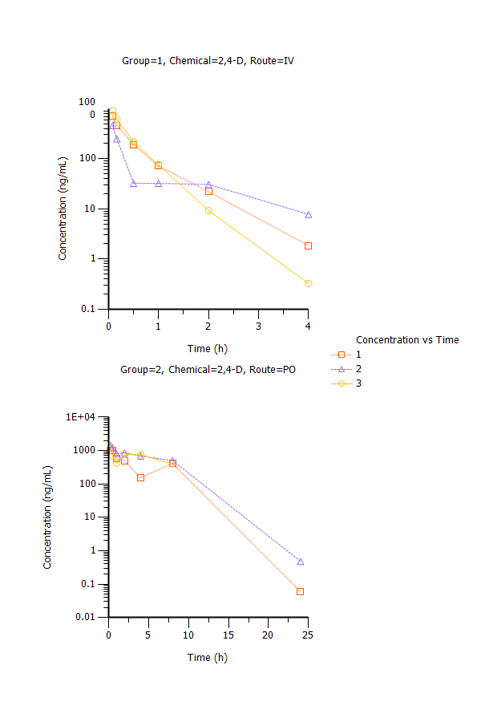

Table 20. Concentration of Alachlor (ng/mL) in Rat Plasma following Intravenous (IV) or Gavage (PO) Administration

|  |  |  |  |  |  |  |
| --- | --- | --- | --- | --- | --- | --- |
|  | IV | IV | IV | PO | PO | PO |
| Time (h) | 3-01 | 3-02 | 3-03 | 4-01 | 4-02 | 4-03 |
| 0.0833 | 69.8 | 0.365 | 46.95 | - | - | - |
| 0.167 | 40.05 | 0.3315 | 34.5 | - | - | - |
| 0.25 | - | - | - | 0.285 | 0.5355 | 0.5185 |
| 0.5 | 10.085 | 0.642 | 9.19 | 0.356 | 0.381 | 0.396 |
| 1 | 3.05 | 1.29 | 3.23 | 0.2385 | 0.3695 | 0.3265 |
| 2 | 1.285 | 2.63 | 1.13 | 0.3105 | 0.3315 | 0.2355 |
| 4 | 0.3485 | 2.705 | 0.411 | 0.2135 | 0.2255 | 0.218 |
| 8 | 0.268 | 1.38 | 0.2805 | *0.1785* | ND | *0.169* |
| 24 | 0.2045 | ND | ND | *0.1315* | 0.137 | ND |
| 48 | ND | ND | ND | ND | ND | ND |
| 72 | ND | ND | ND | ND | ND | ND |

*Italics* = BLOQ (0.2 ng/mL)

Note: Appears IV dosing was bad for 3-02.

Figure 2. Plasma Concentration vs Time for Alachlor following Intravenous or Gavage Administration to Rats

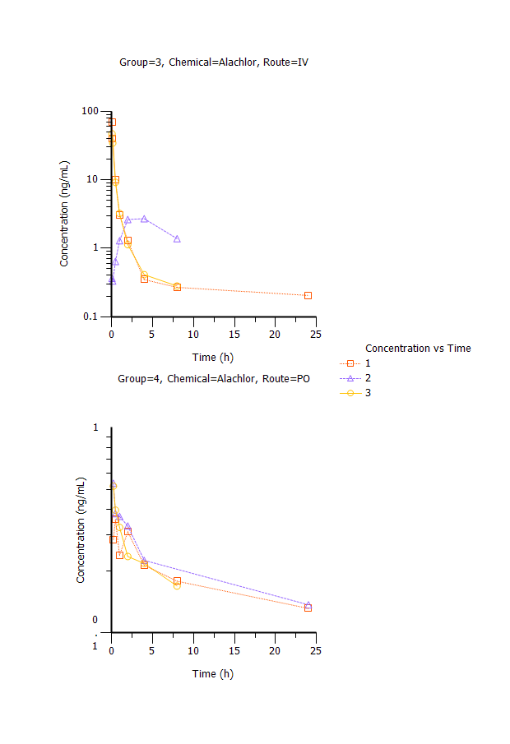

Table 21. Concentration of Flufenacet (ng/mL) in Rat Plasma following Intravenous (IV) or Gavage (PO)_ Administration

|  |  |  |  |  |  |  |
| --- | --- | --- | --- | --- | --- | --- |
|  | IV | IV | IV | PO | PO | PO |
| Time (h) | 5-01 | 5-02 | 5-03 | 6-01 | 6-02 | 6-03 |
| 0.0833 | 48.6 | 195 | 127.5 | - | - | - |
| 0.167 | 20.45 | 80.65 | 52.4 | - | - | - |
| 0.25 | - | - | - | 0.8105 | 2.165 | 0.708 |
| 0.5 | 4.055 | 13.65 | 8.655 | *0.401* | 1.32 | *0.4105* |
| 1 | 3.72 | 1.82 | 4.31 | *0.4505* | *0.4615* | *0.274* |
| 2 | 1.815 | 0.896 | 3.415 | *0.188* | *0.2195* | *0.256* |
| 4 | 2.035 | *0.328* | 2.88 | *0.146* | *0.135* | *0.1985* |
| 8 | 2.105 | *0.0709* | *0.0986* | *0.0824* | *0.11595* | *0.15* |
| 24 | *0.03515* | *0.0595* | *0.04405* | *0.01585* | *0.0179* | *0.02495* |
| 48 | *0.02295* | *0.02645* | *0.02595* | *0.0322* | *0.0128* | *0.017* |
| 72 | *0.0508* | *0.03525* | *0.01207* | *0.02135* | *0.02075* | *0.0224* |

*Italics* = BLOQ (0.5 ng/mL)

Note: Very little PO data is above LOQ.

Figure 3. Plasma Concentration vs Time for Flufenacet following Intravenous or Gavage Administration to Rats

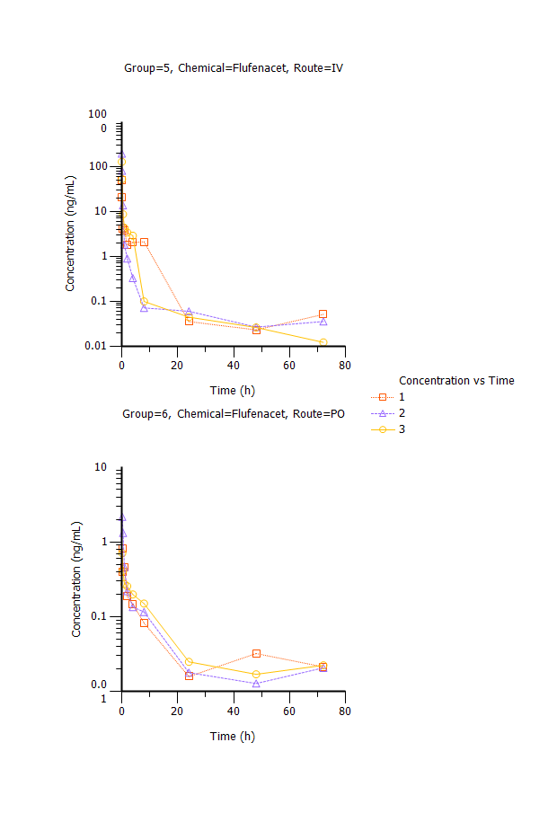

Table 22. Concentration of Chloridazon (ng/mL) in Rat Plasma following Intravenous (IV) or Gavage (PO) Administration

|  |  |  |  |  |  |  |
| --- | --- | --- | --- | --- | --- | --- |
|  | IV | IV | IV | PO | PO | PO |
| Time (h) | 7-01 | 7-02 | 7-03 | 8-01 | 8-02 | 8-03 |
| 0.0833 | 84.5 | 403.5 | 371 | - | - | - |
| 0.167 | 54.25 | 477 | 228.5 | - | - | - |
| 0.25 | - | - | - | 382.5 | 401.5 | 476.5 |
| 0.5 | 144.5 | 349 | 352.5 | 616.5 | 466 | 636 |
| 1 | 88 | 106.1 | 102.05 | 863 | 863 | 858 |
| 2 | 106 | 11.35 | 23.55 | 371 | 337 | 586.5 |
| 4 | 88.35 | 1.035 | 1.66 | 202 | 64.85 | 157.5 |
| 8 | 0.5565 | 1.72 | *0.3325* | 93.2 | 48.85 | 3.03 |
| 24 | *0.0877* | *0.115* | *0.02277* | *0.3285* | 0.604 | 0.913 |
| 48 | *0.02815* | ND | *0.0394* | *0.0714* | *0.0265* | *0.05634* |
| 72 | *0.072* | 0.11595 | ND | ND | *0.01465* | *0.004355* |

*Italics* = BLOQ (0.5 ng/mL)

7-01 IV data suspect - bad dose?

Figure 4. Plasma Concentration vs Time for Chloridazonfollowing Intravenous or Gavage Administration to Rats

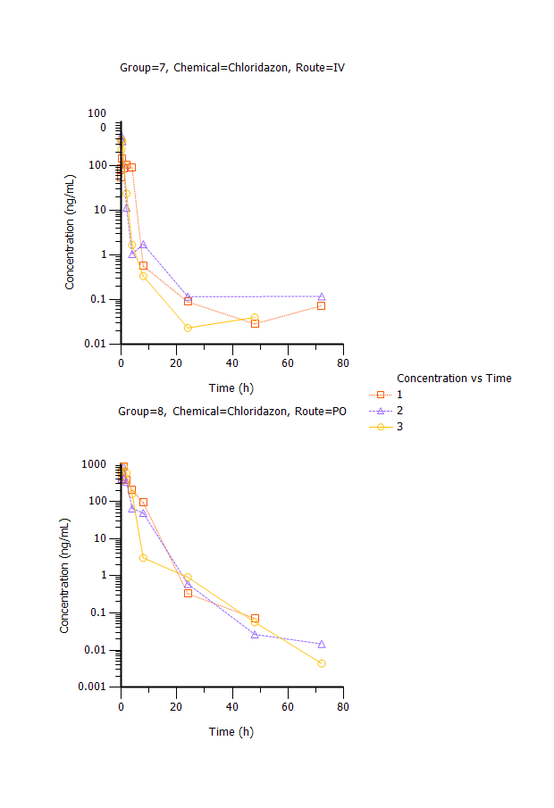

Table 23. Concentration of Bensulide (ng/mL) in Rat Plasma following Intravenous (IV) or Gavage (PO) Administration

|  |  |  |  |  |  |  |
| --- | --- | --- | --- | --- | --- | --- |
|  | IV | IV | IV | PO | PO | PO |
| Time (h) | 9-01 | 9-02 | 9-03 | 10-01 | 10-02 | 10--3 |
| 0.0833 | 1011 | 12.15 | 1000.5 | - | - | - |
| 0.167 | 707.5 | 20.69 | 585 | - | - | - |
| 0.25 | - | - | - | 7.835 | 8.155 | 1.175 |
| 0.5 | 199.5 | 17.4 | 145 | 7.825 | 3.815 | 2.365 |
| 1 | 85.2 | 24.15 | 69.3 | 5.2 | 6.265 | 2.94 |
| 2 | 28.8 | 39.5 | 24.65 | 2.09 | 3.195 | 2.35 |
| 4 | 7.65 | 56.9 | 30.9 | *0.6485* | 1.135 | 1.207 |
| 8 | 1.1475 | 23.55 | 3.685 | ND | 0.0169 | ND |
| 24 | *0.254* | *0.08495* | *0.0312* | ND | 0.00225 | ND |
| 48 | ND | ND | ND | ND | ND | ND |
| 72 | ND | ND | ND | ND | ND | ND |

*Italics* = BLOQ (1 ng/mL)

Note: 9-02 IV data suspect – bad dose?

Figure 5 Plasma Concentration vs Time for Bensulide following Intravenous or Gavage Administration to Rats

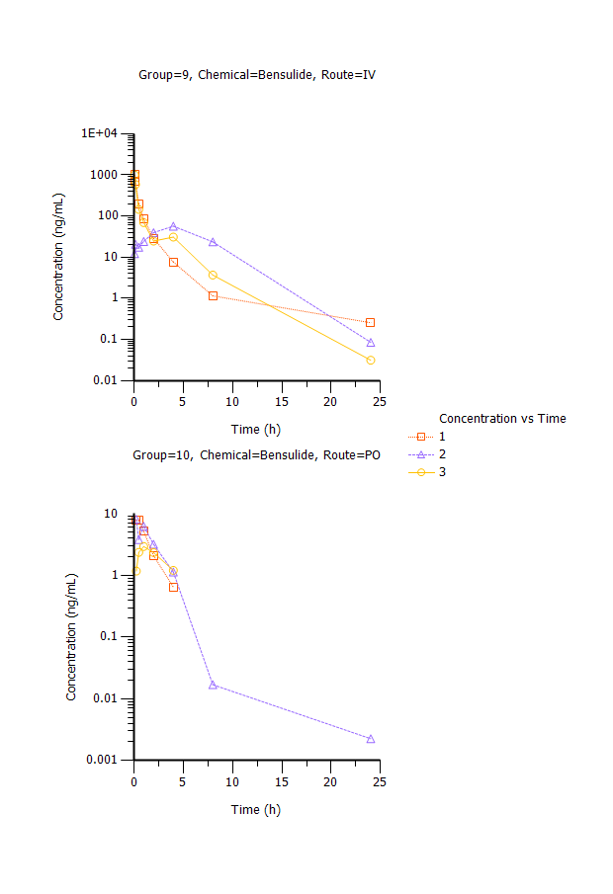

Table 24. Concentration of Propyzamide (ng/mL) in Rat Plasma following Intravenous (IV) or Gavage (PO) Administration

|  |  |  |  |  |  |  |
| --- | --- | --- | --- | --- | --- | --- |
|  | IV | IV | IV | PO | PO | PO |
| Time (h) | 11-01 | 11-02 | 11-03 | 12-01 | 12-02 | 12-03 |
| 0.0833 | 53.35 | 11.05 | 548.5 | - | - | - |
| 0.167 | 34.65 | 9.935 | 386 | - | - | - |
| 0.25 | - | - | - | 251.5 | 217 | 228 |
| 0.5 | 20.15 | No Sample | 184.5 | 359 | 244 | 301.5 |
| 1 | 13.45 | 14.7 | 107.5 | 323 | 205 | 262.5 |
| 2 | 19.5 | 17.2 | 39.4 | 153 | 98.15 | 158 |
| 4 | 27.95 | 54.1 | 19.95 | 174.5 | 159 | 234.5 |
| 8 | 11.795 | 13.35 | 5.825 | 83.5 | 148 | 115.5 |
| 24 | 0.384 | *0.09625* | 0.3275 | 2.23 | 2.89 | 3.065 |
| 48 |  |  |  | 0.3265 | 0.3755 | 0.2685 |
| 72 |  |  |  | *0.0846* | *0.0426* | *0.0997* |

*Italics* = BLOQ (0.2 ng/ml)

Note: Wide variance in IV data.

Figure 6. Plasma Concentration vs Time for Propyzamide following Intravenous or Gavage Administration to Rats

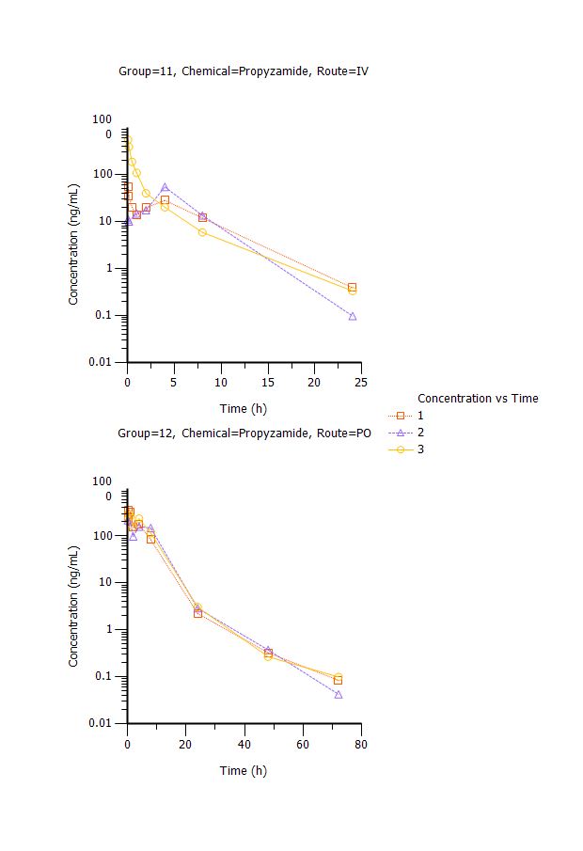

Table 25. Concentration of Pyrithiobac Na (ng/mL) in Rat Plasma following Intravenous (IV) or Gavage (PO) Administration

|  |  |  |  |  |  |  |
| --- | --- | --- | --- | --- | --- | --- |
|  | IV | IV | IV | PO | PO | PO |
| Time (h) | 13-01 | 13-02 | 13-03 | 14-01 | 14-02 | 14-03 |
| 0.0833 | 964 | 1017.5 | 1085 | - | - | - |
| 0.167 | 719.5 | 806 | 754.5 | - | - | - |
| 0.25 | - | - | - | 1085 | 1380 | 1405 |
| 0.5 | 315.5 | 348 | 361 | 1065 | 1555 | 1190 |
| 1 | 92.1 | 119.5 | 124.5 | 1190 | 1090 | 1270 |
| 2 | 28.9 | 22.85 | 35.05 | 458 | 437 | 331 |
| 4 | 2.0855 | 7.725 | 3.885 | 126.5 | 111.5 | 153.5 |
| 8 | 1.185 | 3.245 | 1.56 | 37.05 | 31.95 | 65.6 |
| 24 | *0.0762* | ND | ND | 0.5505 | 0.833 | 1.065 |
| 48 | ND | ND | ND | ND | ND | ND |
| 72 | ND | ND | ND | *0.20595* | ND | ND |

*Italics* = BLOQ (0.5 ng/mL)

Figure 7. Plasma Concentration vs Time for Pyrithiobac Na following Intravenous or Gavage Administration to Rats

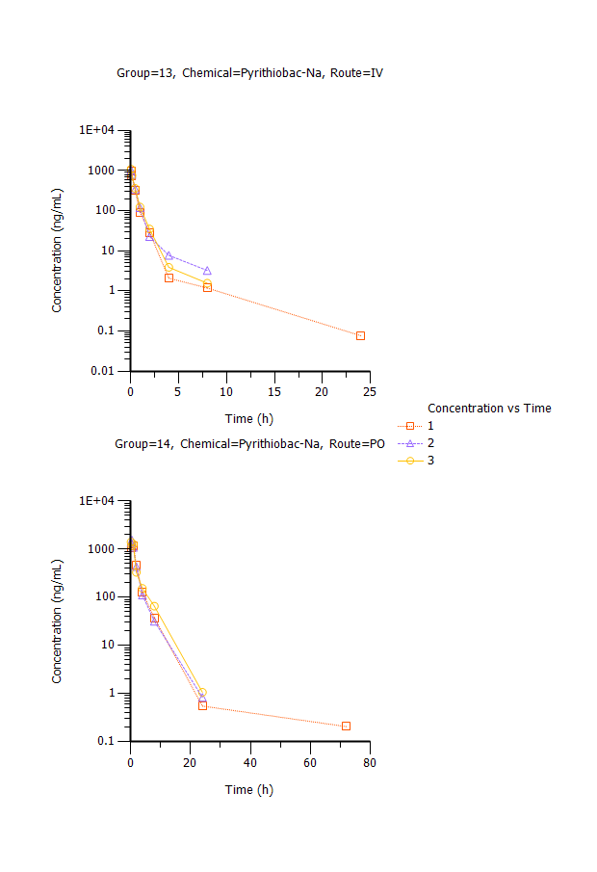

Table 25. Concentration of the Diazoxon Metabolite IMP (ng/mL) in Rat Plasma following Intravenous (IV) or Gavage (PO) Administration

|  |  |  |  |  |  |  |
| --- | --- | --- | --- | --- | --- | --- |
|  | IV | IV | IV | PO | PO | PO |
| Time | 15-01 | 15-02 | 15-03 | 16-01 | 16-02 | 16-03 |
| 0.0833 | 564 | 247 | 213.5 | - | - | - |
| 0.167 | 596 | 373.5 | 337 | - | - | - |
| 0.25 | - | - | - | 915.5 | 1775 | 1220 |
| 0.5 | 597 | 1335 | 349 | 846.5 | 330.5 | 1070 |
| 1 | 356.5 | 413 | 440.5 | 1175 | 1041.5 | 1065 |
| 2 | 271 | 286.5 | 294.5 | 1145 | 786.5 | 948 |
| 4 | 173.5 | 187.5 | 155 | 715 | 745 | 784.5 |
| 8 | 57.85 | 60.85 | 59.55 | 298 | 316 | 291.5 |
| 24 | 1.135 | 0.5525 | 0.498 | 2.63 | 5.045 | 4.31 |
| 48 | <LOQ | 0.0484 | <LOQ | 1.845 | 0.193 | 0.1156 |
| 72 | 0.4815 | <LOQ | 0.2475 | 0.239 | 3.725 | 1.21 |

LOQ – 0.1 ng/mL

Figure 8. Plasma Concentration vs Time for IMP following Intravenous or Gavage Administration to Rats

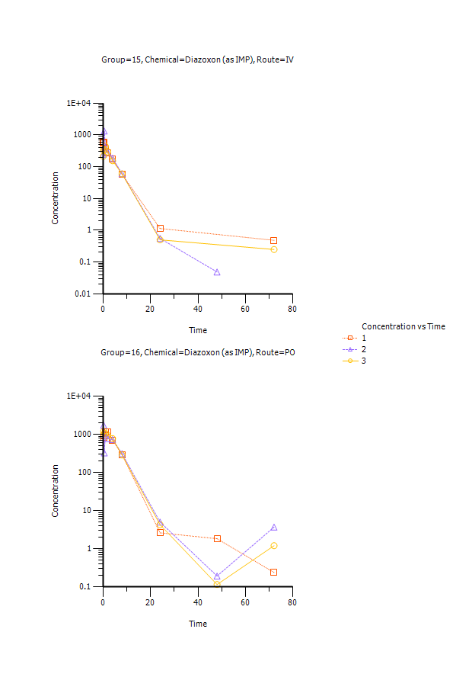

## Pharmacokinetic parameters

Plasma concentration versus time data were analyzed using noncompartmental methods in Phoenix WInNonlin Version 6.3. Pharmacokinetic parameters are presented in Table 26. The model curve fits for each rat are shown in Figure 9

Table 26. Pharmacokinetic Parameters

| Group | Route | Chemical | Replicate | R2 | t1/2 | Tmax | Cmax | AUCall | AUCINF pred | AUCINF/D pred | AUC  %Extra pred | Vz_obs | Cl_obs |
| --- | --- | --- | --- | --- | --- | --- | --- | --- | --- | --- | --- | --- | --- |
| 1 | IV | 2,4-D | 1 | 0.9998 | 0.57 | 0.0833 | 709.5 | 369.8 | 371.4 | 1829.4 | 0.41 | 0.000447 | 0.000547 |
| 1 | IV | 2,4-D | 2 | 0.9195 | 1.16 | 0.0833 | 461 | 237.2 | 250.4 | 1239.8 | 5.29 | 0.001355 | 0.000807 |
| 1 | IV | 2,4-D | 3 | 0.9963 | 0.37 | 0.0833 | 911 | 422.6 | 422.8 | 2023.0 | 0.04 | 0.000267 | 0.000494 |
| **Mean** |  |  |  | **0.9719** | **0.70** | **0.0833** | **693.8** | **343.2** | **348.2** | **1697.4** | **1.91** | **0.0007** | **0.0006** |
| **SD** |  |  |  | **0.0454** | **0.41** | **0.0000** | **225.4** | **95.6** | **88.5** | **408.0** | **2.93** | **0.0006** | **0.0002** |
| 2 | PO | 2,4-D | 1 | *0.2409* | *6.26* | *0.25* | *1029* | *3095.3* | *5451.1* | *5226.4* | *43.22* | *0.001381* | *0.000153* |
| 2 | PO | 2,4-D | 2 | 0.9914 | 7.95 | 0.25 | 1435 | 5797.8 | 11523.4 | 11048.3 | 49.69 | 0.001033 | 9.01E-05 |
| 2 | PO | 2,4-D | 3 | 0.9150 | 6.11 | 0.25 | 1200 | 5050.9 | 8746.3 | 8393.8 | 42.25 | 0.001069 | 0.000121 |
| **Mean** |  |  |  | **0.9532** | **7.03** | **0.2500** | **1317.5** | **5424.3** | **10134.9** | **9721.0** | **45.9689** | **0.0011** | **0.0001** |
| **SD** |  |  |  | **0.0540** | **1.30** | **0.0000** | **166.2** | **528.1** | **1963.7** | **1877.0** | **5.2582** | **0.0000** | **0.0000** |
| 3 | IV | Alachlor | 1 | 0.8980 | 29.04 | 0.0833 | 69.8 | 33.0 | 41.4 | 40.7 | 20.31 | 1.02602 | 0.024488 |
| 3 | IV | Alachlor | 2 |  |  | 4 | 2.705 | 16.2 |  |  |  |  |  |
| 3 | IV | Alachlor | 3 | 0.7917 | 2.20 | 0.0833 | 46.95 | 23.5 | 24.2 | 23.9 | 2.77 | 0.131339 | 0.041403 |
| **Mean** |  |  |  | **0.8448** | **15.62** | **1.3889** | **39.8** | **24.2** | **32.8** | **32.3** | **11.54** | **0.5787** | **0.0329** |
| **SD** |  |  |  | **0.0752** | **18.98** | **2.2613** | **34.1** | **8.4** | **12.2** | **11.8** | **12.40** | **0.6326** | **0.0120** |
| 4 | PO | Alachlor | 1 | 0.2149 | 11.87 | 0.5 | 0.356 | 1.1 | 5.0 | 1.0 | 78.58 | 18.79065 | 1.097209 |
| 4 | PO | Alachlor | 2 | 0.9850 | 4.11 | 0.25 | 0.5355 | 1.3 | 2.6 | 0.5 | 51.46 | 11.72974 | 1.977827 |
| 4 | PO | Alachlor | 3 | 0.9881 | 12.27 | 0.25 | 0.5185 | 1.9 | 4.9 | 0.9 | 61.73 | 19.17713 | 1.083402 |
| **Mean** |  |  |  | **0.7293** | **9.42** | **0.3333** | **0.4700** | **1.4** | **4.2** | **0.8** | **63.92** | **16.5658** | **1.3861** |
| **SD** |  |  |  | **0.4455** | **4.60** | **0.1443** | **0.0991** | **0.4** | **1.3** | **0.3** | **13.69** | **4.1926** | **0.5125** |
| 5 | IV | Flufenacet | 1 | *0.3669* | *2.57* | *0.0833* | *48.6* | *30.6* | *34.8* | *35.1* | *12.01* | *0.095844* | *0.025803* |
| 5 | IV | Flufenacet | 2 | 0.8416 | 0.26 | 0.0833 | 195 | 60.1 | 60.3 | 61.4 | 0.26 | 0.005977 | 0.01624 |
| 5 | IV | Flufenacet | 3 | 0.9240 | 5.44 | 0.0833 | 127.5 | 49.3 | 71.4 | 70.6 | 31.01 | 0.110543 | 0.014078 |
| **Mean** |  |  |  | **0.8828** | **2.85** | **0.0833** | **161.3** | **54.7** | **65.9** | **66.0** | **15.63** | **0.0583** | **0.0152** |
| **SD** |  |  |  | **0.0583** | **3.67** | **0.0000** | **47.7** | **7.7** | **7.9** | **6.5** | **21.74** | **0.0739** | **0.0015** |
| 6 | PO | Flufenacet | 1 |  |  | 0.25 | 0.8105 | 0.1 |  |  |  |  |  |
| 6 | PO | Flufenacet | 2 |  |  | 0.25 | 2.165 | 0.7 |  |  |  |  |  |
| 6 | PO | Flufenacet | 3 |  |  | 0.25 | 0.708 | 0.1 |  |  |  |  |  |
| **Mean** |  |  |  | **#DIV/0!** | **#DIV/0!** | **0.2500** | **1.2278** | **0.3** | **#DIV/0!** | **#DIV/0!** | **#DIV/0!** | **#DIV/0!** | **#DIV/0!** |
| **SD** |  |  |  | **#DIV/0!** | **#DIV/0!** | **0.0000** | **0.8132** | **0.4** | **#DIV/0!** | **#DIV/0!** | **#DIV/0!** | **#DIV/0!** | **#DIV/0!** |
| 7 | IV | Chloridazon | 1 | 0.9110 | 0.74 | 0.5 | 145 | 575.2 | 576.0 | 784.8 | 0.15 | 0.001369 | 0.001275 |
| 7 | IV | Chloridazon | 2 | 0.7083 | 0.92 | 0.167 | 477 | 398.4 | 399.0 | 482.5 | 0.15 | 0.002737 | 0.002064 |
| 7 | IV | Chloridazon | 3 | 0.9994 | 0.51 | 0.0833 | 371 | 364.0 | 365.1 | 431.1 | 0.33 | 0.001698 | 0.002319 |
| **Mean** |  |  |  | **0.8729** | **0.72** | **0.2501** | **331** | **445.8** | **446.7** | **566.1** | **0.21** | **0.0019** | **0.0019** |
| **SD** |  |  |  | **0.1492** | **0.21** | **0.2204** | **170** | **113.3** | **113.2** | **191.1** | **0.10** | **0.0007** | **0.0005** |
| 8 | PO | Chloridazon | 1 | 0.9854 | 3.08 | 1 | 863 | 2323.0 | 2724.3 | 651.4 | 14.73 | 0.006791 | 0.001528 |
| 8 | PO | Chloridazon | 2 | 0.9816 | 2.82 | 1 | 863 | 2115.8 | 2118.4 | 514.4 | 0.13 | 0.00792 | 0.001944 |
| 8 | PO | Chloridazon | 3 | 0.7200 | 2.64 | 1 | 858 | 2391.0 | 2392.9 | 570.3 | 0.08 | 0.006665 | 0.001752 |
| **Mean** |  |  |  | **0.8957** | **2.85** | **1.0000** | **861** | **2276.6** | **2411.9** | **578.7** | **4.98** | **0.0071** | **0.0017** |
| **SD** |  |  |  | **0.1521** | **0.22** | **0.0000** | **3** | **143.4** | **303.4** | **68.9** | **8.45** | **0.0007** | **0.0002** |
| 9 | IV | Bensulide | 1 | 0.9923 | 1.31 | 0.0833 | 1011 | 507.3 | 509.4 | 502.9 | 0.40 | 0.003764 | 0.001988 |
| 9 | IV | Bensulide | 2 |  |  | *4* | *56.9* | *308.2* |  |  |  |  |  |
| 9 | IV | Bensulide | 3 | 0.8909 | 1.62 | 0.0833 | 1000.5 | 525.9 | 534.9 | 518.8 | 1.67 | 0.004516 | 0.001929 |
| **Mean** |  |  |  | **0.9416** | **1.47** | **0.0833** | **1006** | **516.6** | **522.1** | **510.8** | **1.04** | **0.0041** | **0.0020** |
| **SD** |  |  |  | **0.0717** | **0.22** | **0.0000** | **7** | **13.1** | **18.0** | **11.3** | **0.89** | **0.0005** | **0.0000** |
| 10 | PO | Bensulide | 1 | 0.9993 | 0.78 | 0.25 | 7.835 | 9.8 | 12.2 | 2.3 | 19.47 | 0.487366 | 0.431119 |
| 10 | PO | Bensulide | 2 | 0.9953 | 1.23 | 0.25 | 8.155 | 14.1 | 16.1 | 3.1 | 12.29 | 0.56431 | 0.317156 |
| 10 | PO | Bensulide | 3 | 0.9921 | 2.30 | 1 | 2.94 | 8.1 | 12.2 | 2.4 | 33.34 | 1.413008 | 0.426664 |
| **Mean** |  |  |  | **0.9956** | **1.44** | **0.5000** | **6.3** | **10.7** | **13.5** | **2.6** | **21.70** | **0.8216** | **0.3916** |
| **SD** |  |  |  | **0.0036** | **0.78** | **0.4330** | **2.9** | **3.1** | **2.2** | **0.5** | **10.70** | **0.5137** | **0.0645** |
|  |  |  |  |  |  |  |  |  |  |  |  |  |  |
|  |  |  |  |  |  |  |  |  |  |  |  |  |  |
|  |  |  |  |  |  |  |  |  |  |  |  |  |  |
| 11 | IV | Propyzamide | 1 | 1.0000 | 3.23 | 0.08 | 53.35 | 272.3 | 269.5 | 258.4 | 0.66 | 0.018062 | 0.00387 |
| 11 | IV | Propyzamide | 2 |  |  | **4** | **54.1** | **234.3** |  |  |  |  |  |
| 11 | IV | Propyzamide | 3 | 0.9888 | 3.50 | 0.0833 | 548.5 | 495.9 | 497.5 | 477.4 | 0.32 | 0.010568 | 0.002094 |
| **Mean** |  |  |  | **0.9944** | **3.37** | **0.0833** | **300.9** | **384.1** | **383.5** | **367.9** | **0.49** | **0.0143** | **0.0030** |
| **SD** |  |  |  | **0.0079** | **0.19** | **0.0000** | **350.1** | **158.1** | **161.2** | **154.9** | **0.25** | **0.0053** | **0.0013** |
| 12 | PO | Propyzamide | 1 | 0.9537 | 4.65 | 0.5 | 359 | 2076.3 | 2077.6 | 646.8 | 0.06 | 0.010376 | 0.001545 |
| 12 | PO | Propyzamide | 2 | 0.9451 | 4.97 | 0.5 | 244 | 2466.0 | 2467.9 | 795.6 | 0.08 | 0.009008 | 0.001257 |
| 12 | PO | Propyzamide | 3 | 0.9696 | 4.54 | 0.5 | 301.5 | 2527.0 | 2528.2 | 824.3 | 0.05 | 0.007945 | 0.001213 |
| **Mean** |  |  |  | **0.9562** | **4.72** | **0.5000** | **301.5** | **2356.4** | **2357.9** | **755.6** | **0.06** | **0.0091** | **0.0013** |
| **SD** |  |  |  | **0.0124** | **0.22** | **0.0000** | **57.5** | **244.5** | **244.6** | **95.3** | **0.01** | **0.0012** | **0.0002** |
| 13 | IV | Pyrithiobac-Na | 1 | 0.8393 | 0.81 | 0.0833 | 964 | 536.6 | 537.0 | 101.3 | 0.08 | 0.011455 | 0.009858 |
| 13 | IV | Pyrithiobac-Na | 2 | 0.9367 | 2.24 | 0.0833 | 1017.5 | 604.8 | 614.4 | 119.1 | 1.55 | 0.027063 | 0.008384 |
| 13 | IV | Pyrithiobac-Na | 3 | 0.8639 | 0.84 | 0.0833 | 1085 | 623.8 | 624.5 | 121.7 | 0.12 | 0.009915 | 0.008203 |
| **Mean** |  |  |  | **0.8800** | **1.29** | **0.0833** | **1022.2** | **588.4** | **592.0** | **114.0** | **0.58** | **0.0161** | **0.0088** |
| **SD** |  |  |  | **0.0507** | **0.82** | **0.0000** | **60.6** | **45.9** | **47.8** | **11.1** | **0.84** | **0.0095** | **0.0009** |
| 14 | PO | Pyrithiobac-Na | 1 | 0.9993 | 2.57 | 1 | 1190 | 3004.5 | 3006.5 | 2904.9 | 0.07 | 0.001278 | 0.000344 |
| 14 | PO | Pyrithiobac-Na | 2 | 0.9966 | 2.89 | 0.5 | 1555 | 3061.8 | 3065.1 | 2978.8 | 0.11 | 0.001399 | 0.000336 |
| 14 | PO | Pyrithiobac-Na | 3 | 0.9991 | 2.76 | 0.25 | 1405 | 3371.5 | 3375.8 | 3221.2 | 0.13 | 0.001236 | 0.00031 |
| **Mean** |  |  |  | **0.9983** | **2.74** | **0.5833** | **1383** | **3145.9** | **3149.2** | **3035.0** | **0.10** | **0.0013** | **0.0003** |
| **SD** |  |  |  | **0.0015** | **0.16** | **0.3819** | **183** | **197.4** | **198.5** | **165.5** | **0.03** | **0.0001** | **0.0000** |
| 15 | IV | Diazoxon-(as IMP) | 1 | 0.7754 | 7.09 | 0.5 | 597 | 2264.2 | 2266.0 | 6511.6 | 0.08 | 0.00157 | 0.000154 |
| 15 | IV | Diazoxon-(as IMP) | 2 | 0.9519 | 3.46 | 0.5 | 1335 | 2586.9 | 2587.0 | 7761.8 | 0.00 | 0.000644 | 0.000129 |
| 15 | IV | Diazoxon-(as IMP) | 3 | 0.7481 | 6.65 | 1 | 440.5 | 2096.8 | 2097.6 | 5920.5 | 0.04 | 0.001622 | 0.000169 |
| **Mean** |  |  |  | **0.8251** | **5.74** | **0.6667** | **790.8** | **2315.9** | **2316.9** | **6731.3** | **0.04** | **0.0013** | **0.0002** |
| **SD** |  |  |  | **0.1106** | **1.98** | **0.2887** | **477.7** | **249.1** | **248.6** | **940.1** | **0.04** | **0.0006** | **0.0000** |
|  |  |  |  |  |  |  |  |  |  |  |  |  |  |
|  |  |  |  |  |  |  |  |  |  |  |  |  |  |
|  |  |  |  |  |  |  |  |  |  |  |  |  |  |
| 16 | PO | Diazoxon-(as IMP) | 1 | 0.8711 | 5.79 | 1 | 1175 | 8369.8 | 8370.7 | 4994.8 | 0.01 | 0.001674 | 0.0002 |
| 16 | PO | Diazoxon-(as IMP) | 2 | 0.7092 | 6.76 | 0.25 | 1775 | 8073.8 | 8076.7 | 4673.8 | 0.04 | 0.002088 | 0.000214 |
| 16 | PO | Diazoxon-(as IMP) | 3 | 0.7898 | 5.65 | 0.25 | 1220 | 8299.0 | 8299.8 | 4889.7 | 0.01 | 0.001668 | 0.000205 |
| **Mean** |  |  |  | **0.7900** | **6.07** | **0.5000** | **1390** | **8247.5** | **8249.1** | **4852.7** | **0.02** | **0.0018** | **0.0002** |
| **SD** |  |  |  | **0.0810** | **0.60** | **0.4330** | **334** | **154.6** | **153.4** | **163.7** | **0.02** | **0.0002** | **0.0000** |

Figure 9. WinNonlin Curve Fits

